horizontal line

**EE208:CONTROL ENGINEERING LAB 08**

**Stability and instability of nonlinear systems**

**Course Instructor : Dr. Sanjay Roy**

**Date : 21th March 2022**



**Group Number - 14**

**Raj Kumar Deb 2020eeb1025**

**Tushar Sharma 2020eeb1325**

**Tiya Jain 2020eeb1213**

# TABLE OF CONTENTS

**TABLE OF CONTENTS** **2**

**1. OBJECTIVE** **3**

**2. GIVEN INFORMATION** **3**

**3. INTRODUCTION** **4**

Figure 3.1 Overhead Crane 4

**4. SCHEMATIC DIAGRAM** **5**

Figure 3.1 Schematic diagram for the given system 5

**5. Determination of equilibrium/critical points:** **5**

**5. Linearisation at particular points** **6**

Case 1 : Linearisation at x3 = 0 6

Case 2 : Linearisation at x3 = π 7

**6. OBSERVATIONS & THEIR ANALYSIS** **8**

Figure 6.1 Step Response of X1 for different Gains 8

Figure 6.2 Step Response of X1 for different ml 9

Figure 6.3 Step Response of X1 for different l 9

Figure 6.4 Root Locus of X1 10

6.1 Tracking of the movement of eigenvalues as parameters assume different values and ranges 10

6.1.1 Variating parameter ml (from 0 to several hundred kgs) 10

Figure 6.1.1 The variation in eigen values with respect to ml 11

6.1.2 Variating parameter l (>1 metre) 11

Figure 6.1.2 The variation in eigen values with respect to l and ml 11

6.1.3 Variating both parameter 11

Figure 6.1.3 The variation in eigen values with respect to both l and 12

Table 6.1.3 Trends observed in above graphs 12

6.2 Observability and controllability analysis 13

6.3 Finding and examining the local and global nature of stability and instability points and their features 13

**7. CONCLUSION** **14**

**8. MATLAB SCRIPTS** **15**

# 1. OBJECTIVE

* To examine stability features of a given nonlinear system by observing movement of eigenvalues across the s-plane.
* To locate the different equilibria for the problem and examining the local and global nature

# 

# 2. GIVEN INFORMATION

* Differential equation of a simplified model of an overhead crane:
* Parameters :
  + Arbitrary :
  + Constant:
* Variables :
  + Input:
    - u: Force in Newtons, applied to the trolley.
  + Output:
    - y: Position of load in metres, . y(t) = x1(t) + l . sin x3(t)
  + States:
    - x1: Position of trolley in metres.
    - x2: Speed of trolley in m/s.
    - x3: Rope angle in rad/s.
    - x4: Angular speed of rope in rad/s

# 

# 3. INTRODUCTION

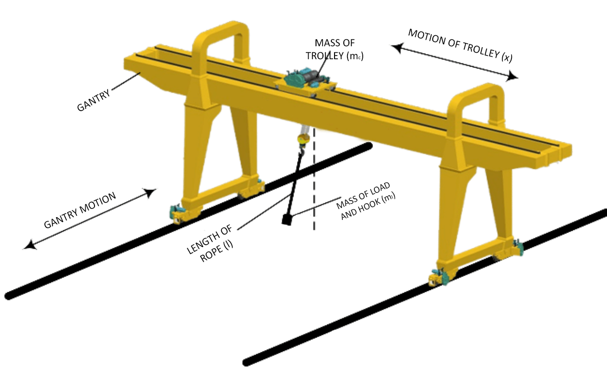

#### Figure 3.1 Overhead Crane

At any point of time, the system is completely described by the given four states .

From given definitions of x1 and x2, we can infer that .

The only input ‘u’ is the force applied to the trolley(in horizontal direction and hence affects the rate of change of speed i.e. x2’). And the output position is given by y(t) = x1(t) + l.sin(x3(t))

Using arithmetic operations from the given differential equations we also derive the x’ = f (x, u,t) form for x2’ and x4’

**where**

# 4. SCHEMATIC DIAGRAM



#### Figure 3.1 Schematic diagram for the given system

# 5. Determination of equilibrium/critical points:

Substituting for x1’ = x2 and x3’ = x4 in the given differential equations in order to avoid the complications due to double derivative terms ,we get:

Now to determine the equilibrium points, we put the time derivative of all the state variables equal to 0 in these equations

So, for x1’=x2 = 0; x2’ = 0; x3’=x4 = 0; x4’ =0, in first equation we get u(t) = 0;

And from the second equation we get sin(x3(t)) = 0.

So we conclude that for the equilibrium points x2 = x4 = 0 ; and x3 is an integral multiple of π, x1 has no specific conditions to satisfy in particular.

As all the cases for even multiples of π are identical, and those for odd π are also identical. So, we take only the values x3 = 0 and x3 = π for our analysis. But as we are considering the motion such that the value of angle varies from -π/2 to π/2 radians (since motion is constrained in an overhead crane), we focus more on the equilibrium point where x3 = 0.

So our state vector at equilibrium can be denoted as and ; where x1 = k is arbitrary but a constant value at a given time (it denotes the position of the trolley in the horizontal line).

# 5. Linearisation at particular points

## Case 1 : Linearisation at = 0

For this overhead crane model the linearization is done at a point where rope angle i.e. x3 = 0 rad. Around the equilibrium point, and our nonlinear equations get reduced to:

; ; ;

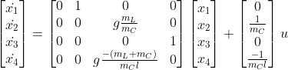

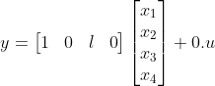

## 

## Case 2 : Linearisation at = π

For this overhead crane model the linearization is done at a point where rope angle i.e. x3 = 0 rad. Around the equilibrium point, and our nonlinear equations get reduced to:

; ; ;

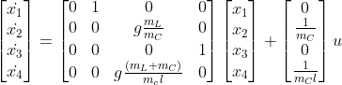

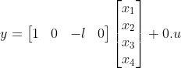

Since the state vectors with x3 = π rads are impractical situations and further since we get the eigenvalues for such cases of the type (0, 0, a, -a); i.e. two poles at origin, and two real values of same magnitude but opposite sign(which indicates instability), we restrict our further analysis around the equilibrium points for which x3 = 0 rads only.

# 

# 

# 6. OBSERVATIONS & THEIR ANALYSIS

| Figure 6.1 Step Response of X1 for different Gains | * In the feedback response for K = [1,1000] of distance travelled by trolley, we can notice that as the gain value increases the system becomes unstable faster. * This might also be due to computation errors as our transfer function has **two pair of poles** of the form . |
| --- | --- |
| Figure 6.2 Step Response of X1 for different ml | * While observing the dependence of mass of load + hook on the step response, we see that as the *ml* grows, the step response becomes less unstable. * The linearised form of X1(s) is & * ⇒ The step response ∝ *ml*. |
| Figure 6.3 Step Response of X1 for different l | * Step response for different values of length of the rope was observed. There was no difference in the responses i.e. the **step response doesn’t depend** on the **length of the rope**. * This is evident from the above eqn of Y(s). |
| Figure 6.4 Root Locus of X1 | * From the following rlocus plot of the dynamic system, we can see that the movement of poles occurs in conjugate pole pairs. This is noticeable from the characteristic polynomial of X(s) which is of the form , that gives us two conjugate pole pairs. * So the system will be marginally stable for all positive values of gain. |

## 

## 

## 

## 6.1 Tracking of the movement of eigenvalues as parameters assume different values and ranges

In the variation of parameters, we observed that we always achieve the eigenvalues of the x1 to be of the form . Two of the poles are at the origin and a purely complex pole pair is attained for x1. Therefore, the following graph is to be interpreted as the |ib| on the y-axis and the variating parameter on the x-axis.

### 6.1.1 Variating parameter *ml* (*from 0 to several hundred kgs*)

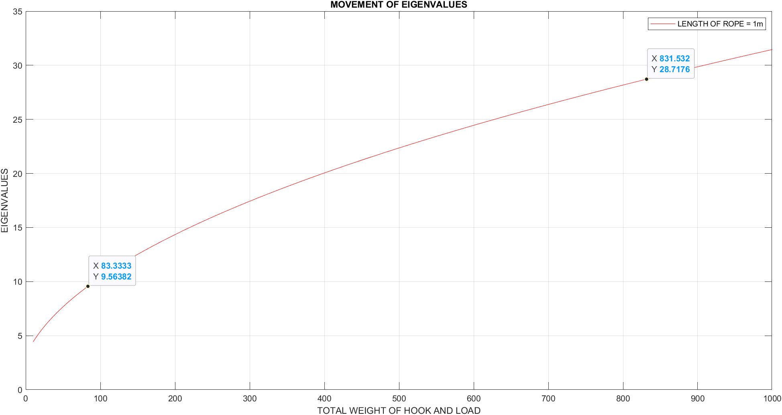

#### Figure 6.1.1 The variation in eigen values with respect to ***ml***

### 6.1.2 Variating parameter *l* (*>1 metre*)

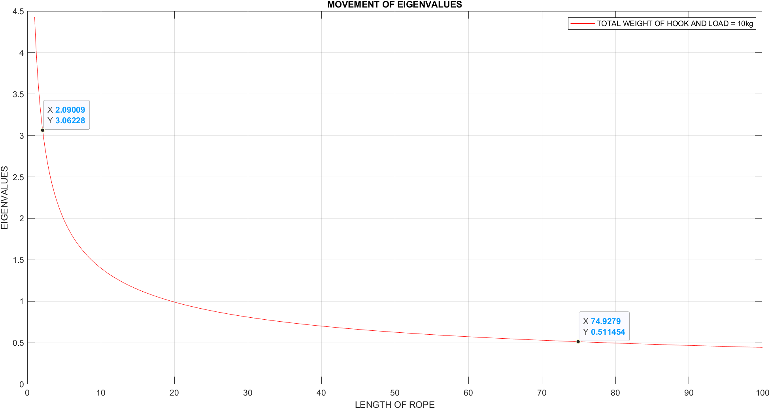

#### Figure 6.1.2 The variation in eigen values with respect to l and ml

### 

### 6.1.3 Variating both parameter

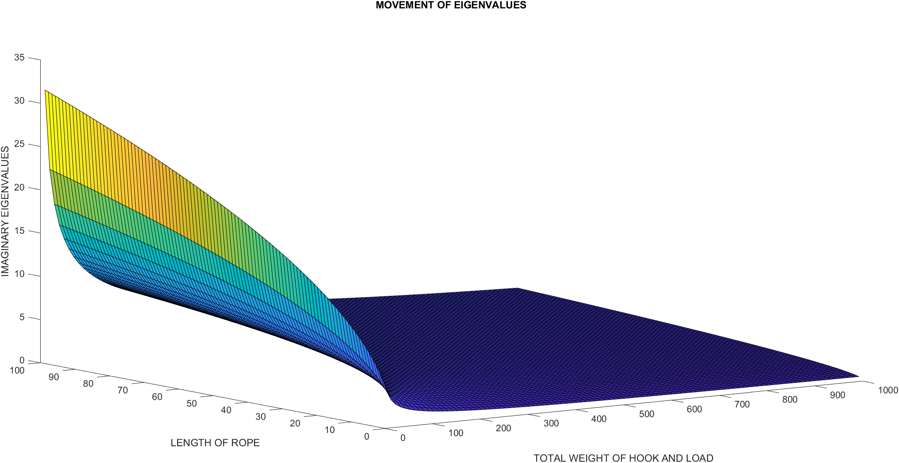

#### Figure 6.1.3 The variation in eigen values with respect to both l and

| **Variating Parameter** | ***ml* (10kg-1000kg)** | ***l* (1m-10m)** |
| --- | --- | --- |
| Nature of Curve | Non-linear | Non-linear |
| Values when parameters | Goes to inf | Goes to 0 |
| Relation with Eigenvalue | Direct | Inverse |

#### Table 6.1.3 Trends observed in above graphs

* We have complex pair of poles i.e. the natural frequency of this system will be ⍵n2 = b2.
* We can see that the damping ratio for this linearised form will be 0 i.e. the system will be oscillatory.

## 

## 6.2 Observability and controllability analysis

The conditions of complete state controllability:

Controllability Matrix () = [] . After substituting the values in this matrix to control over all the states , we should have rank =4 and matrix A should be non- singular but our conditions are not satisfied and hence, our system is not controllable.

The observability matrix can be found using the formula given below:

Observability Matrix () = []T should have 4 linearly independent column vectors to imply the existence of a complete solution to the control design problem.



## 6.3 Finding and examining the local and global nature of stability and instability points and their features

Using Lyapunov stability theorem :

From the continuous lyapunov equation X = lyap(A,Q)

that solves the Lyapunov equation

+*X*+*Q* = 0

We had to take the Q matrix as an arbitrary positive definite matrix and thus we took it as the identity matrix(for simplicity). If we are able to obtain a X symmetric matrix then the system should be stable , but we didn’t get any positive results for the matrix of X using the above lyap function in

Therefore , using Lyapunov stability, we didn’t get any unique solution for any positive definite matrix of Q. Therefore, the system is not stable at any point. It is in unstable equilibrium.

# 

# 7. CONCLUSION

* The given nonlinear system was linearised about all the equilibrium points, which were found to be of the formand ; where k is arbitrary but a constant value at a given time.
* The movement of eigenvalues was tracked and observed with respect to the parameters *mL* and *l*. It was found to be dependent non-linearly. The parameter *mL* was in direct relationship with the eigenvalues and the parameter *l* was inverse relationship with the eigenvalues.
* The linearised system poles/eigenvalues were found to be of the form (0, 0, 士 4.4272*i*) for F = 1N, ml = 10kg, l =1m.
* The observability and controllability were also analysed using , and we found that the system is neither controllable or observable.
* We concluded that the crane system was not stable at any point but was marginally stable at the equilibrium point of the form where k is an arbitrary constant, with input force u = 0. On Lyapunov analysis we found that for equilibrium points with as points of global instability.
* Further this is expected as for example, if we keep applying a constant non zero force on the trolley then its speed increases ( increases) and so does the distance ( increases) continuously and the trolley does not tend to return to its previous position, instead it keeps going away from there until input force is further changed.
* The load at the rope will remain in oscillatory motion until any force is applied on it (ideally), as there is no resisting force to stop the motion of the load. Therefore we get marginal instability.

# 

# 

# 

# 8. MATLAB SCRIPTS

